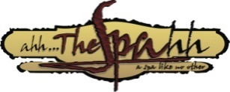
19 Broadway St. W. Paris ON N3L 2S3
(519) 442-9772 www.ahhthespa.com

Mothers Day Packages 2024

Shellac Mani & Spa Pedicure………………………$95

45 Minute Ayurvedic Indian Head Massage…………$75

Spa Pedicure & Yonka Complete Facial……………...$155

30 minute Relaxation Massage & Yonka Complete Facial $150

30 min Relaxation Massage & 30 Min Salt Water Float ..$75

*Half Day of Pampering - 45 minute Relaxation Massage, Yonka
Complete Facial & Spa Pedicure 3 hrs $ 220

*Full Day of Luxury -Dead Sea Mud Wrap, Anti Aging Facial,
Spa Mani Retreat & Spa Pedi Retreat with Warm Paraffin Wax. 5 hrs………………..$360

- 15% Gratuity must be paid at time of purchase for half & Full Days

Gift Certificates Available in any dollar denomination as well.
Mothers Day Specials Available until May 12,2024

We look Forward Too Spoiling your loved ones

